Cowboy Boot Dish Cloth
© Vicki Meldrum 2006
Vicki Designs

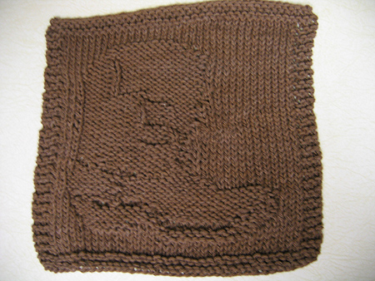

Size 6 or 7 needles
CO 40 stitches

Stitch Glossary: (These stitches are done to show the boot stitching and sole shaping of the boot.)
KTBL, SBK: (Knit Through the Back Loop, Slip Back Knit) Knit the next stitch through the back loop. Slip the same stitch from the right hand needle to the left hand needle and knit it normally
KSB, KTBL: (Knit Slip Back, Knit Through the Back Loop) Knit the next stitch, slip it back on the left hand needle. Knit the same stitch through the back loop.

Row 1-4: Knit
Row 5: K3, P34, K3
Row 6: K
Row 7: K3, P34, K3
Row 8: K10, P11, K19
Row 9: K3, P6, K5, P4, K13, P6, K3
Row 10: K8, P4, (KTBL, SBK) 9x, P2, K2, P7, K8
Row 11: K3, P5, K10, (KSB, KTBL)1x, K9, (KSB, KTBL) 2x, K3, P4, K3
Row 12: K6, P3, (KTBL,SBK)1x, P12, (KTBL,SBK)1x, P10, K7
Row 13: K3, P4, K9, (KSB, KTBL)1x, K14, , (KSB, KTBL) 1x, K2, P3, K3
Row 14: K6, P1, (KTBL, SBK) 1x, P16, (KTBL, SBK)6x, P4, K6
Row 15: K3, P3, K1, (KSB, KTBL) 3x, K2, (KSB, KTBL)1x, K21,P3, K3
Row 16: K7, P20, (KTBL, SBK)1x, P6, K6
Row 17: K3, P2, K7, (KSB, KTBL)1x, K13, P11, K3
Row 18: K15, P12, (KTBL,SBK)1x, P9, K3
Row 19: K3, P2, K7, (KSB, KTBL)1x, K2, (KSB, KTBL)5x, K5, P12, K3
Row 20: K17, P3, (KTBL, SBK)1x, P5, (KTBL,SBK)3x, K11
Row 21: K3, P3, K1, (KSB, KTBL)1x, K11, (KSB, KTBL)1x, K3, P14, K3
Row 22: K17, P2, (KTBL, SBK)1x, P14, K6
Row 23: K3, P3, K15, KSB, KTBL)1x, K1, P14, K3
Row 24: K17, P4, K3, P10, K6
Row 25: K3, P3, K9, P1, K3,P1, K3, P14, K3
Row 26: K17, P3, K1, P13, K6
Row 27: K3, P3, K13, P1, K3, P14, K3
Row 28: K16, P5, K3, P13, K3
Row 29: K3, P3, K9, P1, K8, P13, K3
Row 30: K16, P8, K1, P9, K6
Row 31: K3, P3, K9, P1, K8, P13, K3
Row 32: K16, P4, K1, P3, K1, P9, K6
Row 33: K3, P3, K10, P3, K5, P13, K3
Row 34: K15, P19, K6
Row 35: K3, P3, K5, P5, K9, P12, K3
Row 36: K15, P13, K1, P5, K6
Row 37: K3, P3, K5, P1, K13, P12, K3
Row 38: K15, P13, K1, P5, K6
Row 39: K3, P3, K5, P1, K13, P12, K3
Row 40: K15, P13, K1, P5, K6
Row 41: K3, P4, K4, P1, K13, P12, K3
Row 42: K16, P12, K1, P4, K7
Row 43: K3, P5, K15, P14, K3
Row 44: K18, P13, K9
Row 45: K3, P7, K10, P17, K3
Row 46: Knit
Row 47: K3, P34, K3
Row 48: Knit
Row 49: K3, P34, K3
Row 50-53: Knit
Bind off

©Vicki Meldrum 2006
Vicki Designs
You may print this pattern for your personal use and link to this pattern on this website. You may not print this pattern on any other website without permission.

